THE ULTIMATE CAULIFLOWER CHEESE

In the early days of spring, when there is still a chill in the air, this is the ultimate comfort dish. Buy the very best quality cheddar you can find, and add a generous amount of mustard, to really accentuate the cheesy flavour. Nutmeg and black pepper add a note of spiciness and warmth, whilst the finely chopped Italian flat leaved parsley adds freshness and colour.
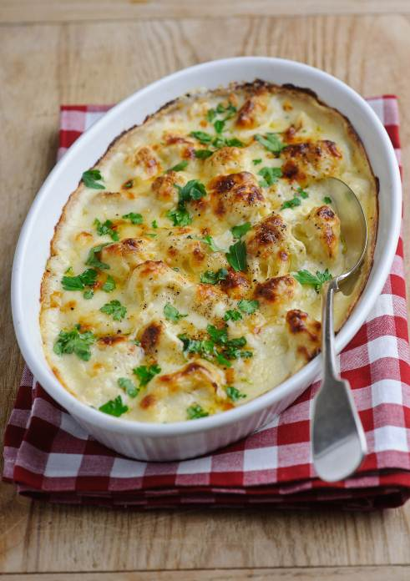
Serves 4

Preparation time: 20 minutes

Cooking time: 5-10 minutes under a hot grill

You’ll need:

1 cauliflower
50g of unsalted butter, plus a bit extra for the ovenproof dish
50g plain flour
300ml milk
A generous grating of nutmeg
Freshly grated black pepper
1 tbsp French grainy mustard, like Dijon
125g Cheddar cheese, freshly grated.
A handful of flat leaved parsley, finely chopped

What to do:

- Firstly prepare the cauliflower by washing it and cutting it into individual little florets, with all the hard woody stems cut off. Place the florets in a double boiler and steam until they are soft and yielding when pierced with a sharp knife. Remove the cauliflower florets from the heat and place in a buttered, ovenproof serving dish.

- Melt the butter in a saucepan. Stir in the flour and cook gently for 1 minute. Remove the butter and flour from the heat and stir in the milk, very gradually. Bring the milky mixture to the boil, and then continue cooking and stirring on a medium heat, until the sauce thickens.

- Pre-heat the grill to its hottest setting.

- Stir the nutmeg, freshly grated black pepper and the mustard into the sauce, along with half the grated cheese. Pour the sauce over the hot cauliflower, sprinkle with the remaining cheese and brown under the hot grill.

- Serve with freshly chopped parsley sprinkled on top.

For more information please contact The Little Big Voice on (0) 208 338 0188 or email pressoffice@thelittlebigvoice.com

