Brussels Sprout and Cranberry Salad

Serves: 4

Preparation time: 15 minutes

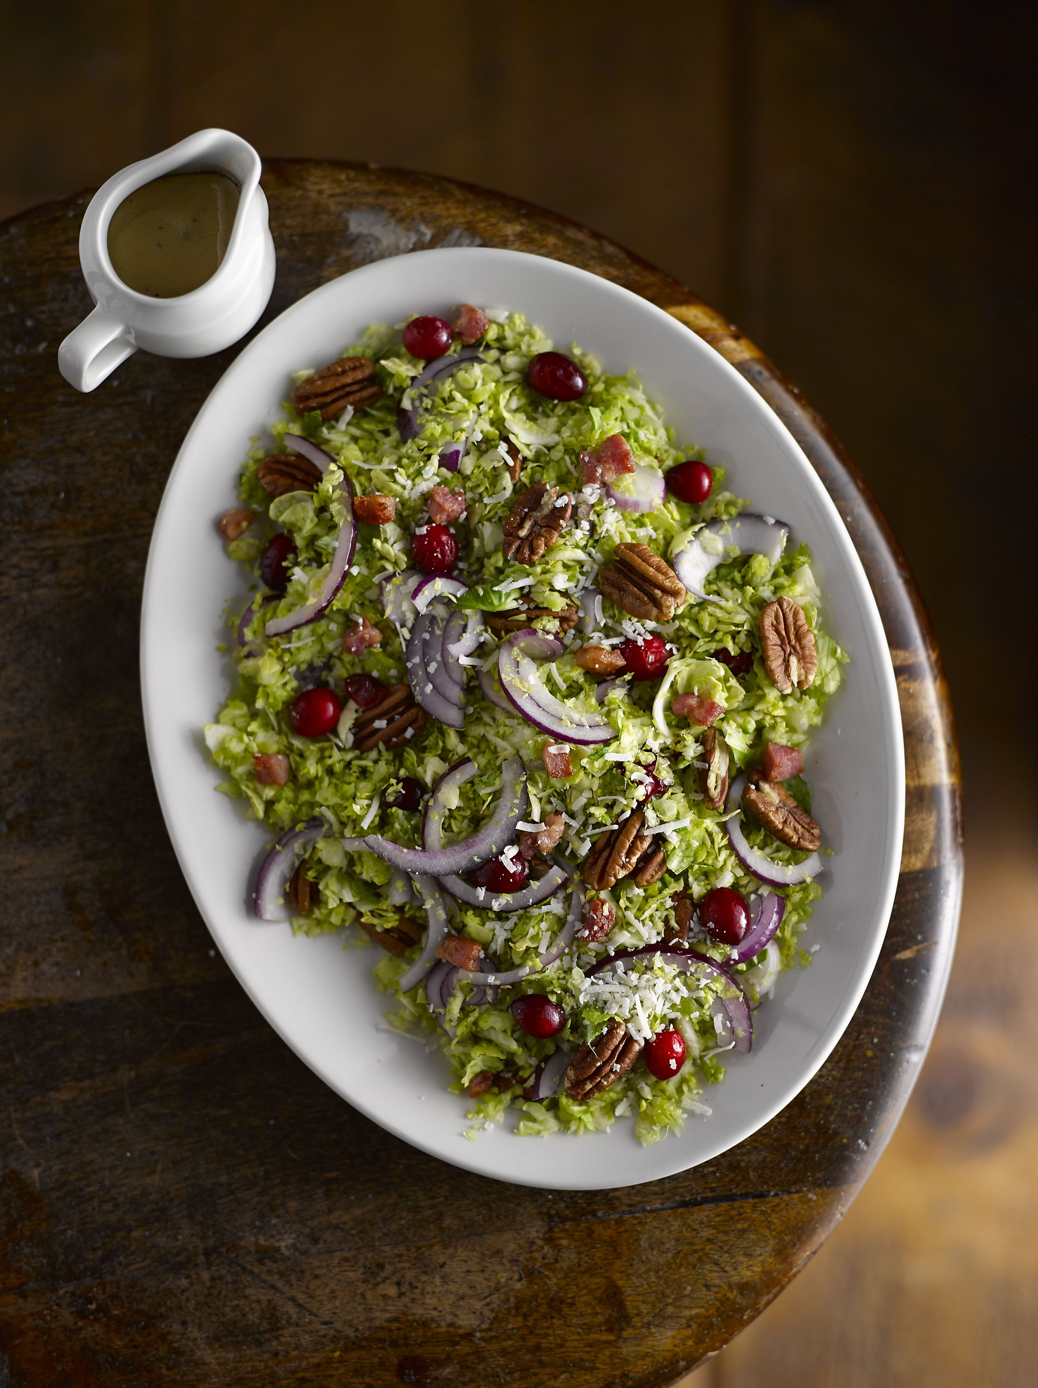
Ingredients:

280g shaved Brussels sprouts
60g dried cranberries, cut into pieces
50g pancetta, diced
30g pecan nuts, chopped into small pieces
30g parmesan cheese shavings (you can use a vegetable peeler to achieve thin shavings)
1 small red onion, sliced thinly
2 tablespoons cider vinegar
2 tablespoons Dijon mustard
1 clove of garlic, crushed and chopped into very small pieces
4 tablespoons olive oil (you may need to add a little more if the dressing needs it)
50ml lemon juice
¼ teaspoon maple syrup
Salt and pepper, to season

What to do:

- Whisk together the vinegar, mustard, garlic, oil, lemon juice, syrup and salt and pepper until completely combined
- Mix the sprouts, cranberries, pancetta, pecans, and onion together in a large bowl, before pouring over your salad dressing
- Toss all of the ingredients together to make sure the salad is completed coated, then cover with cling film and put in the fridge for up to an hour
- Before serving, sprinkle over the parmesan shavings

For more information please contact The Little Big Voice on (0) 208 338 0188 or email pressoffice@thelittlebigvoice.com

