Honey Roast Turnip and Pumpkin

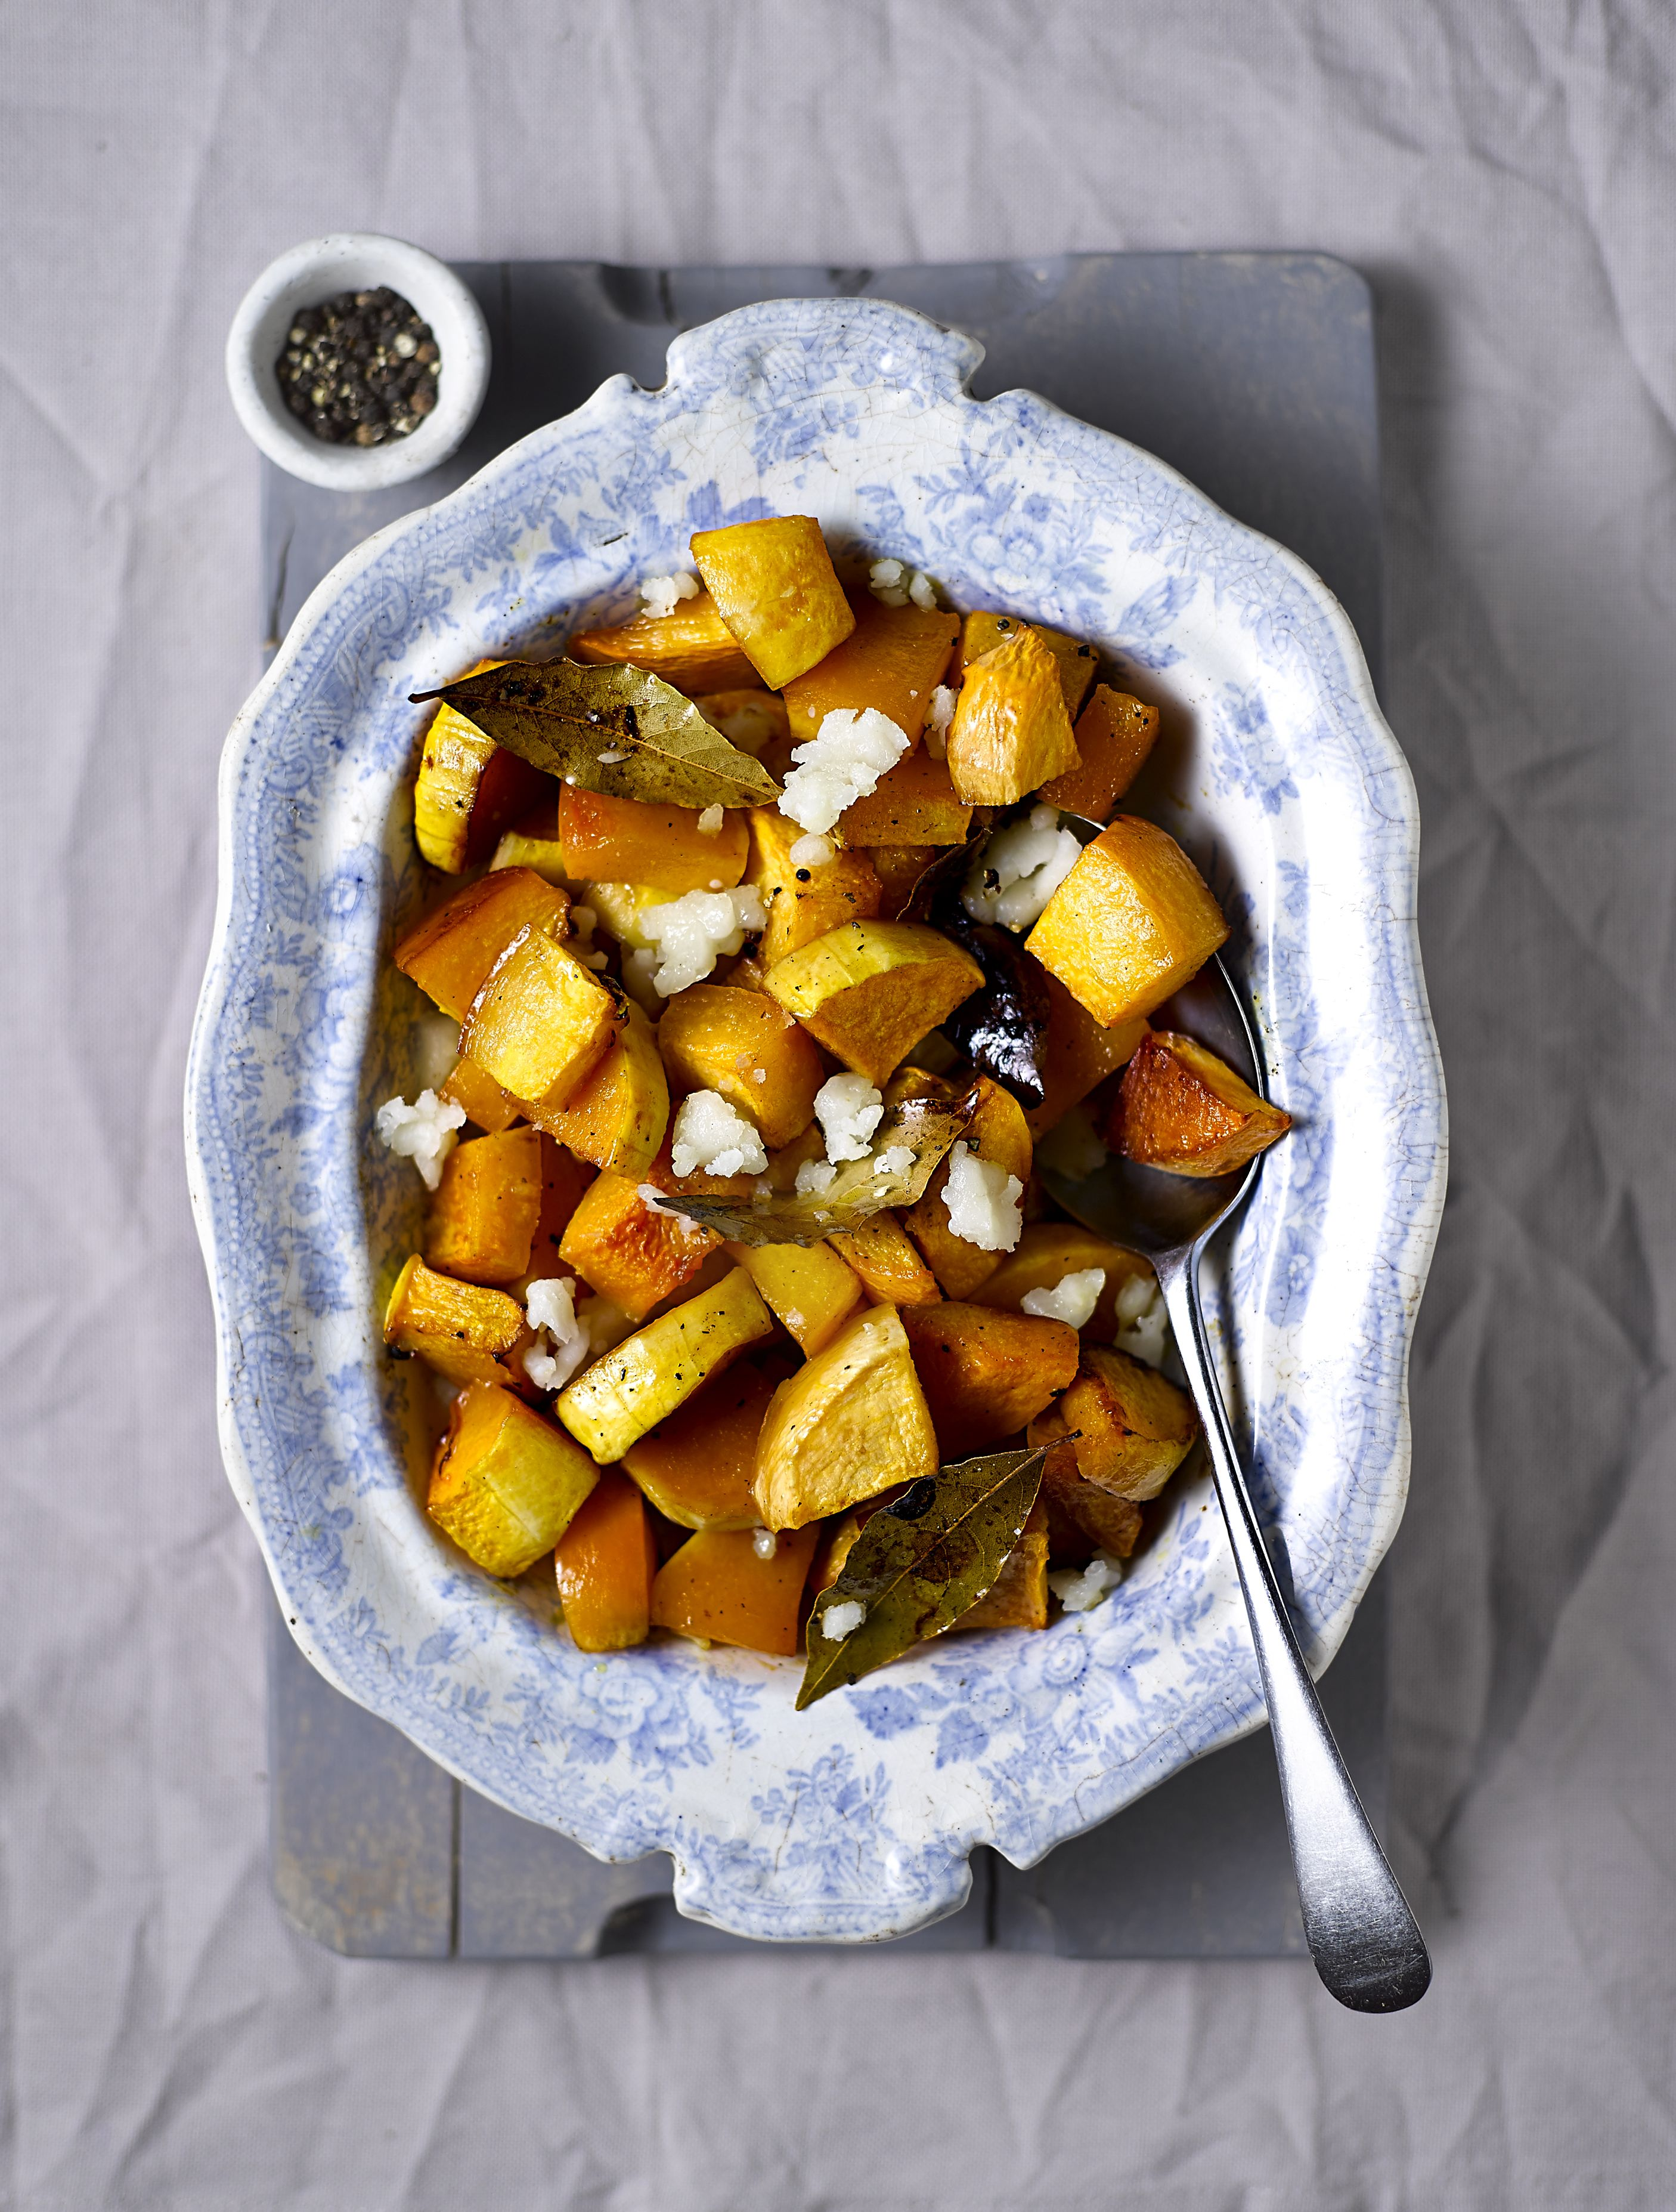
Serves 4
Preparation time: 15 minutes
Cooking time: 25 minutes
Ingredients:

1 medium turnip, peeled and halved
1 small pumpkins, peeled, seeds removed and chopped into chunks
1 garlic clove, peeled
4 bay leaves
Zest and juice of one orange
1 tbsp honey
1 tbsp olive oil
Salt
150g soft goats cheese

What to do:

- Preheat oven to 180°C
- Cut the garlic clove in half, then rub the inside of an oven-proof dish with it
- Parboil the turnips and once softened slightly, drain and put to one side
- Mix together the orange juice, zest, honey and oil
- Put the turnips and pumpkin into the oven dish, and then pour the orange glaze over the top, mixing the vegetables until completely coated
- Add in the remaining garlic, scatter over the bay leaves and add a pinch of salt
- Put the dish into the oven for 25 minutes, or until the vegetables look roasted and ready. Remove from the oven, crumble the goats cheese over the top, then let it melt a little before serving.

For more information please contact The Little Big Voice on (0) 208 338 0188 or email pressoffice@thelittlebigvoice.com

