Kale Tabouli Salad

Makes approx 500g of salad
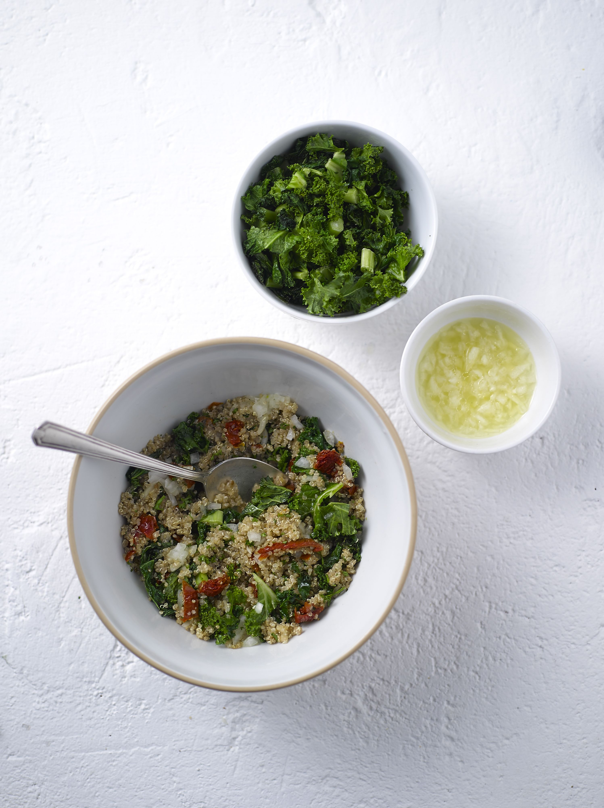
Ingredients:

60g dry quinoa
125ml boiling water
Bunch of kale, sliced
1 small onion, diced finely
Juice of one lemon
Tablespoon olive oil
Handful chopped flat parsley
100g sundried tomatoes, chopped
Pinch of salt

What to do:

- Cook quinoa according to the packet instructions
- Heat some of the oil in a pan on a medium heat. Add the kale and salt, and sauté until the kale changes colour to a brighter shade of green
- Transfer to a large bowl and leave to cool
- Pour the lemon juice into a small bowl and tip in the onion. Leave to marinade a little
- Combine the quinoa, parsley and tomatoes with the kale, mixing thoroughly
- Add olive oil to the lemon juice and onion, then whisk up and pour into the kale and quinoa mix
- Toss all of the ingredients together and serve immediately

Tip: If you want to prepare the tabouli ahead of time, don’t add the dressing until just before you’re ready to serve

For more information please contact The Little Big Voice on (0) 208 338 0188 or email pressoffice@thelittlebigvoice.com

