Roasted Broccoli and Cauliflower with Lemon and Garlic

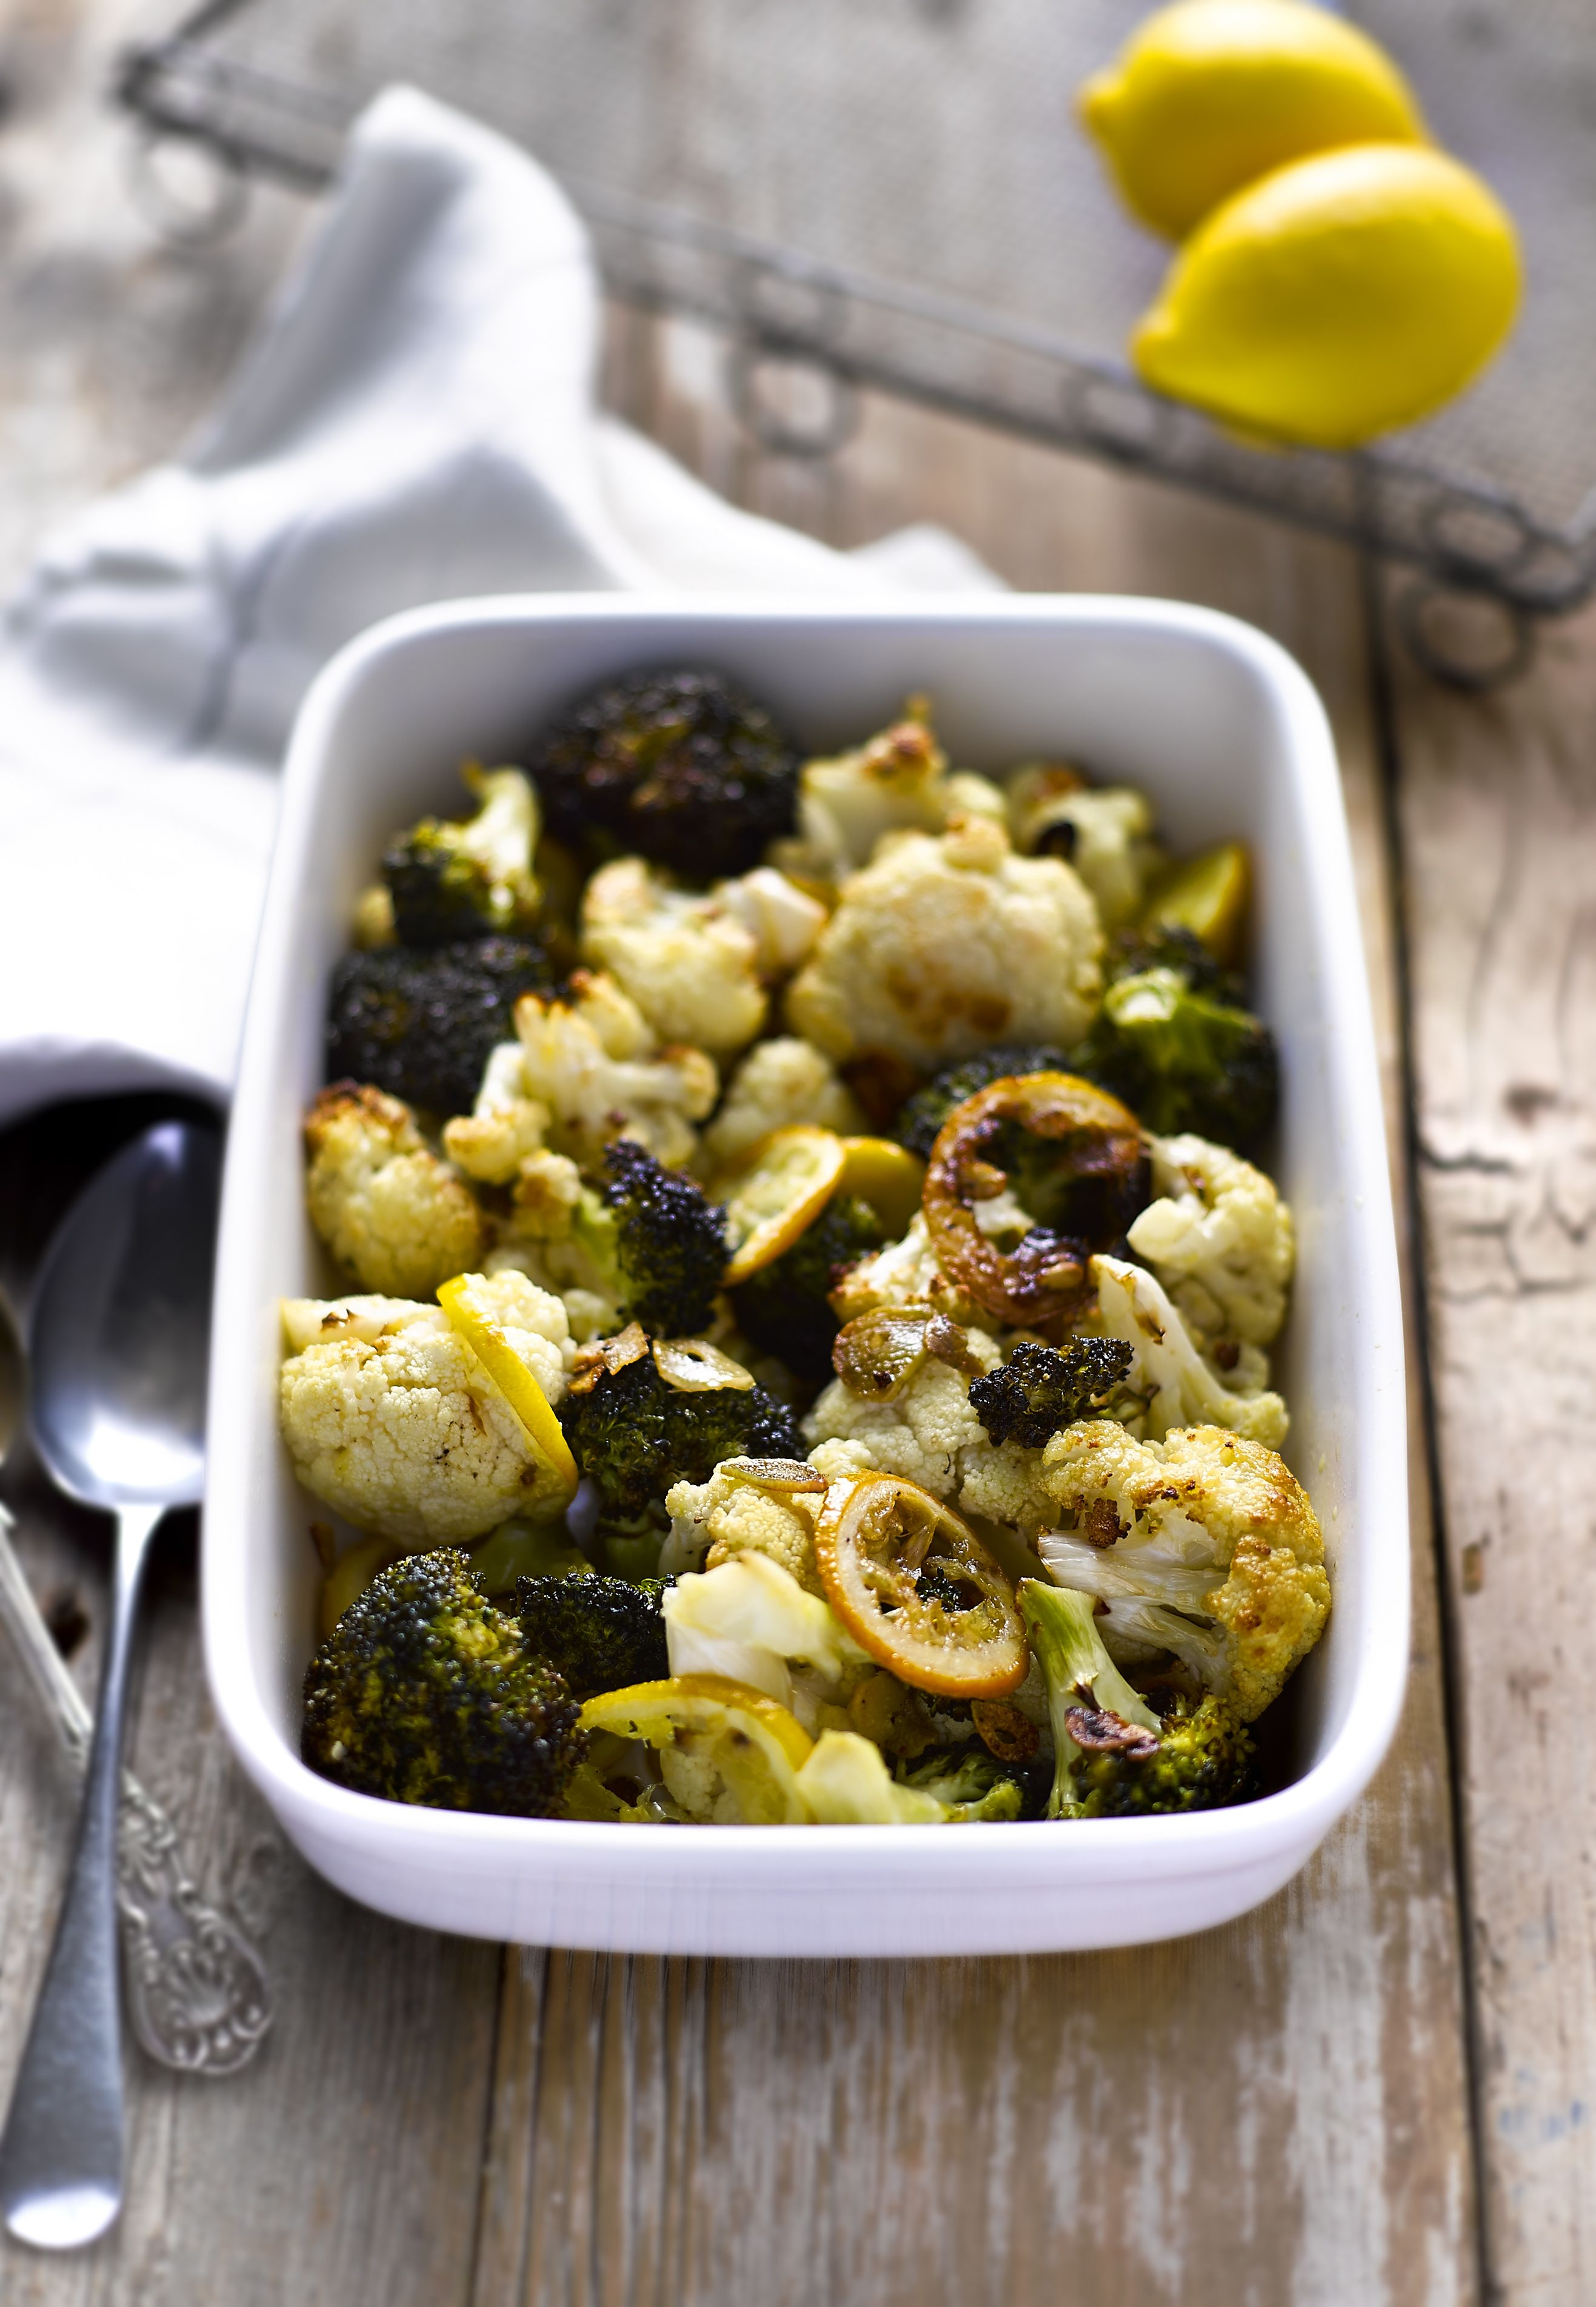
Serves: 4

Preparation time: 10 minutes

Cooking time: 30 minutes

Ingredients:

1 head of broccoli, broken into small florets
1 large head of cauliflower, broken into small florets
3 tablespoons olive oil
4 garlic cloves, sliced thinly
2 lemons, sliced thinly
Salt and pepper, to season

What to do:

- Preheat your oven to 220°C
- Mix all of the ingredients in a large bowl until coated in the oil
- Tip them out onto a baking tray – you may need two
- Roast in the oven for 25 to 30 minutes, tossing the vegetables halfway through cooking time
- Remove from the oven once they are brown and tender
- Serve immediately!

For more information please contact The Little Big Voice on (0) 208 338 0188 or email pressoffice@thelittlebigvoice.com

