Swede Cake

Preparation time: 15 minutes

Cooking time: 50 minutes (30 mins cooking, 10 mins cooling, 10 mins for frosting)

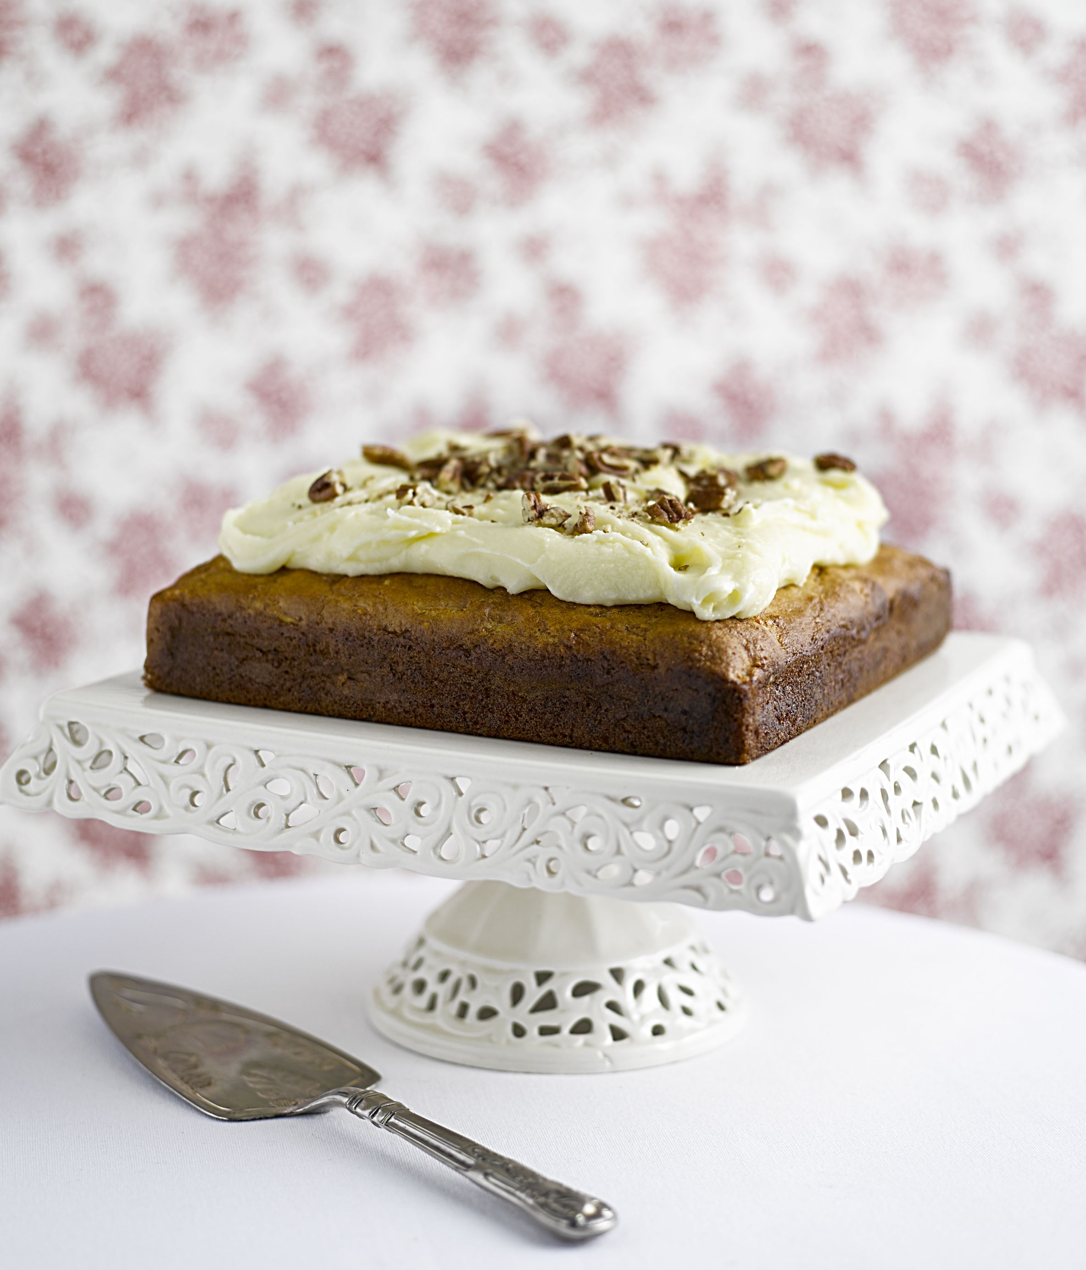
Ingredients:

150g swede, peeled and grated – squeeze any excess moisture out using kitchen towel
3 eggs
100ml vegetable oil
100g natural yoghurt
175g caster sugar
2 teaspoons vanilla extract
250g plain flour
2 teaspoons baking powder
½ teaspoon bicarbonate of soda
2 teaspoons ground nutmeg
Pinch of salt

Frosting:

110g butter
110g cream cheese
250g icing sugar
1 teaspoon vanilla extract

What to do:

- Preheat oven to 180°C, and grease a 9inch square cake tin, then line with greaseproof paper
- In a large bowl, beat together the sugar, eggs, yoghurt, oil and vanilla essence
- Pour in the grated swede and mix together
- Next, add in the flour, baking powder, bicarb, nutmeg and salt and stir until combined completely
- Using a spatula, pour the mixture into your cake tin and bake for 25 to 30 minutes – a skewer inserted into the centre of the cake should come out clean
- Leave in the tin to cool for 10 minutes before tipping out onto a cooling rack. Remove the greaseproof paper and leave until completely cool

- For the cream cheese frosting: beat together the butter and cream cheese, then add the icing sugar a little at a time until smooth and creamy. Add a drop of vanilla extract

- Cover the top of the cake with the frosting, and then dust with a little grated nutmeg. Chopped nuts would also make a great decoration

- Cut into squares and serve

For more information please contact The Little Big Voice on (0) 208 338 0188 or email pressoffice@thelittlebigvoice.com

