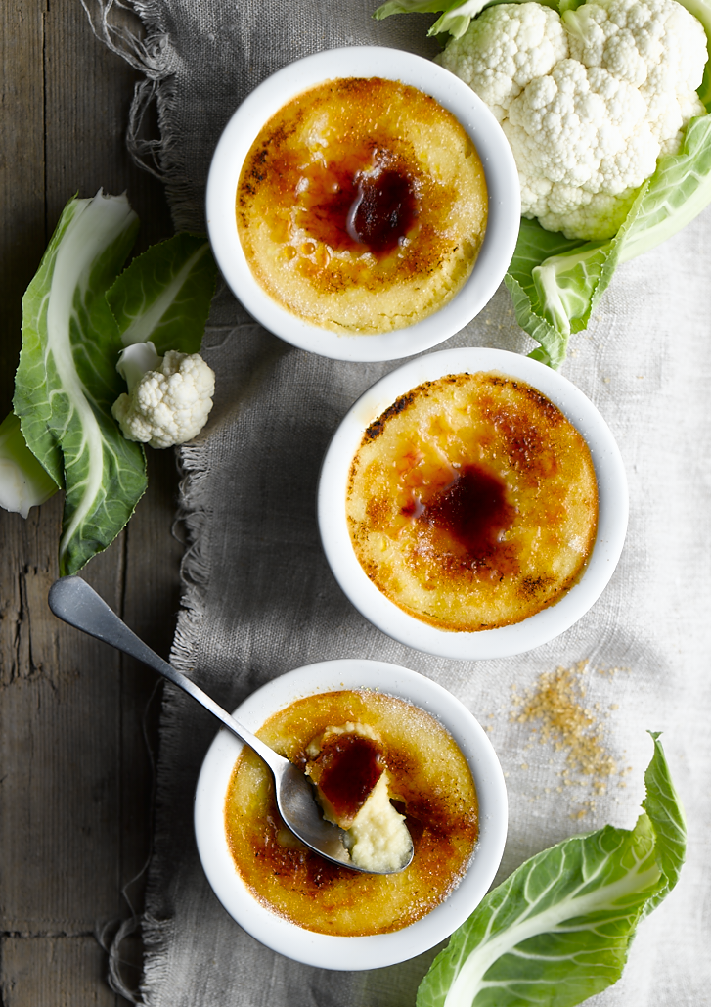
Cauliflower Crème Brulee

Preparation time: 20 minutes
Cooking time: 1 hour

Serves: 4

Ingredients:

12 egg yolks
220g caster sugar
200g cauliflower florets (finely sliced)
1 litre Greek yoghurt
1 tbsp vanilla extract
50g brown sugar

What to do:

- Boil the Greek yoghurt, vanilla and cauliflower in a pan. Bring to boil then simmer til the cauliflower is tender.

- Blend in a food processor, and then pass through a sieve.

- Whisk the egg yolks and sugar. Add the yoghurt to the egg mix and pour into ramekins.

- Sit the ramekins in a water bath in the oven at 110°c for 60 mins or until set.

- Once cooled, sprinkle with brown sugar and caramelise with a torch or grill.

For more information please contact The Little Big Voice on (0) 208 338 0188 or email pressoffice@thelittlebigvoice.com

