Chinese Cabbage and Chicken Noodle Soup

Preparation time: 10 minutes
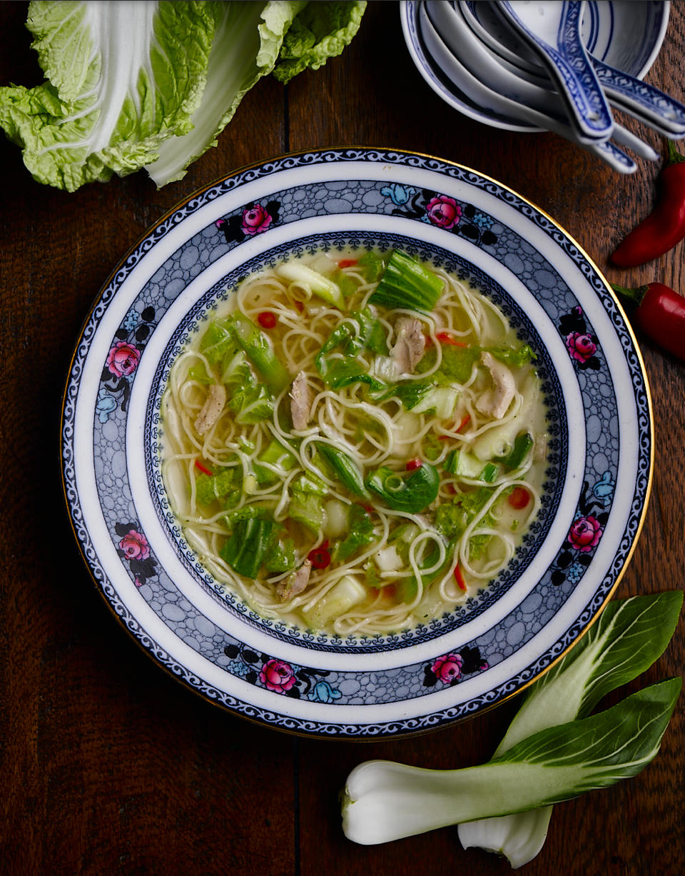
Cooking time: 10 minutes

Serves: 4

Ingredients:

Splash of olive oil
Chinese cabbage, shredded
10 spring onions, roughly sliced diagonally
1 onion, diced
2cm knob of ginger, finely chopped
2 cloves garlic, roughly chopped
1 red chilli, deseeded and julienned
1 pak choi, white and green parts separated and shredded
2 chicken thighs, skin and bone removed, flesh chopped into strips
1 pinches ground allspice
1 dashes of soy sauce
1 litre hot chicken stock
1 stick lemongrass, bruised
150g egg noodles
2 tbsp coriander, chopped

What to do:

- Put the spring onion into a pan with a little oil. Add the onion, ginger, garlic, chilli, Chinese cabbage; the white parts of the pak choi and a pinch of salt and cook over a medium heat until everything begins to soften slightly.
- Add the chicken and allspice. Stir around and continue to cook for a minute or two then pour in the soy sauce and hot chicken stock. Bring to the boil, then toss in the green tops of the pak choi, the lemongrass and noodles and give the pan a good stir.
- Leave to cook for 5 minutes or until the noodles are softened. Once ready check the seasoning, add 2 tablespoons of chopped coriander, stir and serve.

For more information please contact The Little Big Voice on (0) 208 338 0188 or email pressoffice@thelittlebigvoice.com

