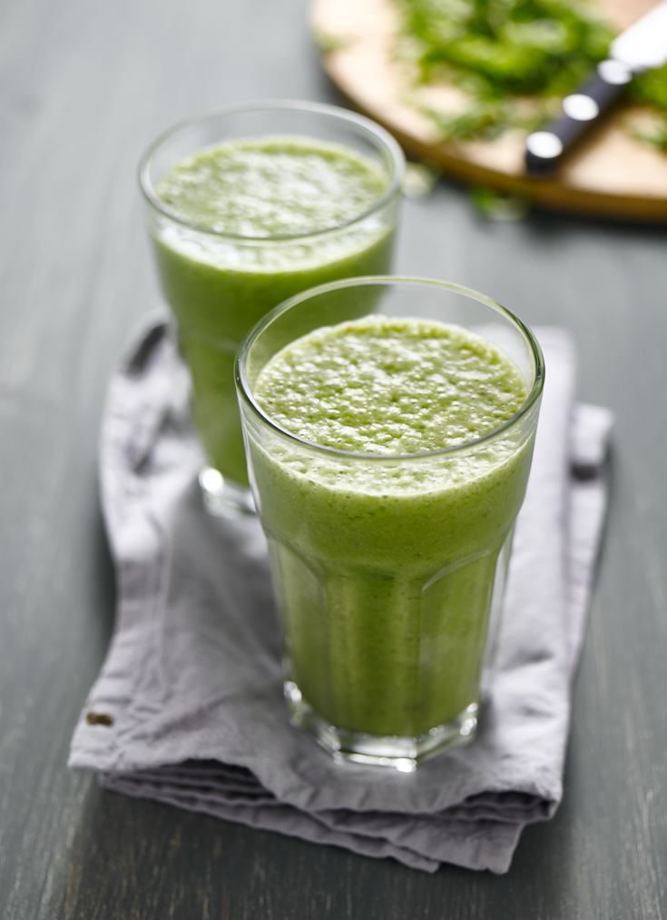
Kale and Banana Shake

Preparation time: 5 minutes
Cooking time: 15 minutes

Serves: 2

Ingredients:

250g kale
1 large or 2 medium bananas
500ml water
40g raw cashews
3 tbsp honey
1 cup of ice
1 tsp vanilla extract

What to do:

- Add the kale, cashews, ice and water in to a juice blender and blend well.

- Pass liquid through a sieve then pour back in to the juicer (clean any pulse out first)

- Now add the banana, vanilla and the honey blend till smooth then pour into a large glass.

For more information please contact The Little Big Voice on (0) 208 338 0188 or email pressoffice@thelittlebigvoice.com

