Roasted Kohlrabi Crostini

Preparation time: 15 minutes
Cooking time: 35 minutes

Serves: 4

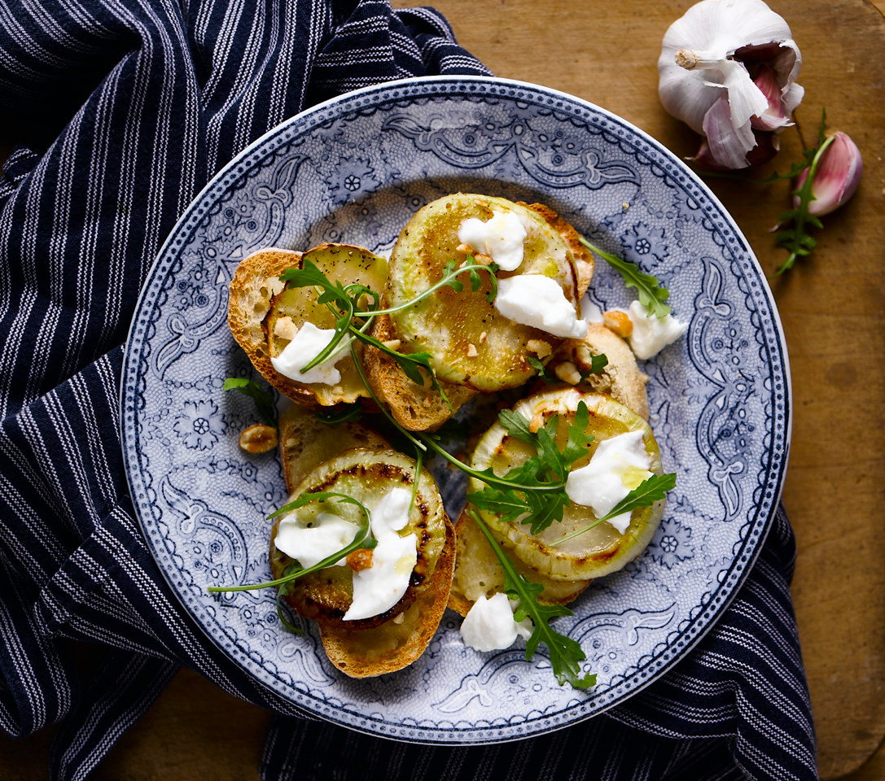
Ingredients:

1 pear, peeled, deseeded and cubed
1 clove of garlic
160ml water
1 tsp honey
1 ball of burrata
100g rocket
1 packet honey roasted peanuts
4 thin slices of ciabatta bread
Sprig of fresh thyme

What to do:

- Slice the kohlrabi in to 4 disks, drizzle with olive oil and honey, salt and pepper and roast on baking paper at 165°C for 25 minutes.

- Toast or grill the bread then rub with the clove of garlic.

- Whilst the kohlrabi is roasting, put the pear, thyme and water in to a small pot and bring to the boil, then blend in a juicer to make a puree.

- Now to assemble. Spoon the pear puree over the toasted bread and place the roasted kohlrabi on top followed by simply tearing the burrata over the crostini.

- Garnish with some crisp peppery rocket and sprinkle with the crushed peanuts, drizzle with good olive oil.

For more information please contact The Little Big Voice on (0) 208 338 0188 or email pressoffice@thelittlebigvoice.com

