Sprout Kebabs

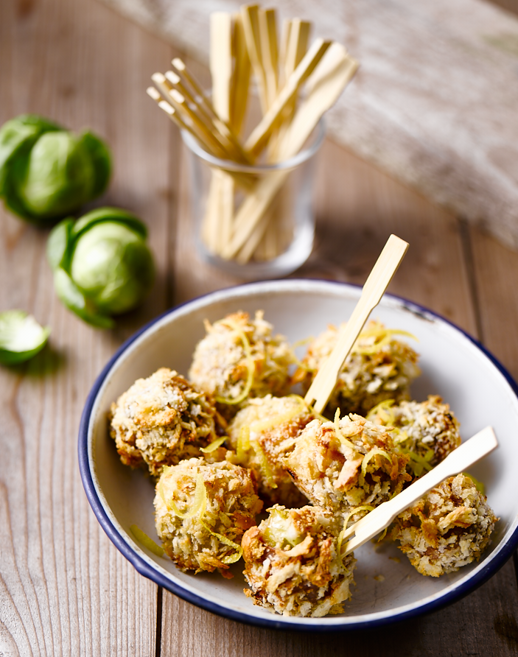
Preparation time: 20 minutes
Cooking time: 25 minutes

Serves: 6

Ingredients:

300g Brussels sprouts, trimmed and washed
1 tbsp Maple syrup
6 slices of Parma ham
100g Parmesan cheese grated
200g panko bread crumbs
1 lemon, zested
1 egg
30g plain flour
Salt and pepper, to taste
1 tsp olive oil for cooking
Cocktail sticks

What to do:

- In a roasting pan, drizzle the sprouts with the maple syrup, olive oil and salt and pepper then roast for 15 minutes at 160°C.

- When cooked let them cool down then wrap the sprouts with Parma ham then put them onto the cocktail sticks.

- Whisk the egg, then dust the sprouts in the flour then dip in the egg and roll in the breadcrumbs, parmesan and lemon zest.

- Put the breaded sprouts on some baking paper then bake in the oven 190°C for 8-10 minutes.

- Dollop some crème fraiche or Greek yogurt to dip.

For more information please contact The Little Big Voice on (0) 208 338 0188 or email pressoffice@thelittlebigvoice.com

