Swede Ice Cream

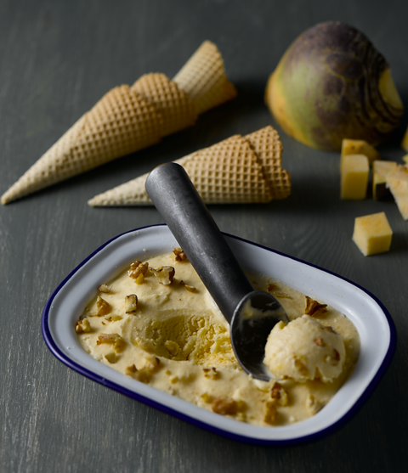
Preparation time: 20 minutes
Cooking time: 4 hours

Serves: 4

Ingredients:

300g peeled, diced swede
500ml mascarpone cheese
1tbsp honey
210g caster sugar
1 vanilla pod
4 egg yolks
4 egg whites

What to do:

- In a pan boil the mascarpone, honey, vanilla and swede. Bring to the boil, and add 10g of caster sugar.

- Boil until the swede is soft then puree using a blender.

- Cool the puree and whip the mascarpone. Fold the puree into the mascarpone and whisk in the egg yolks.

- Whisk the egg whites til they form soft peaks and fold into the mascarpone and swede mixture.

- Pour into ice cream tubs and set in the freezer for at least 4 hours.

For more information please contact The Little Big Voice on (0) 208 338 0188 or email pressoffice@thelittlebigvoice.com

