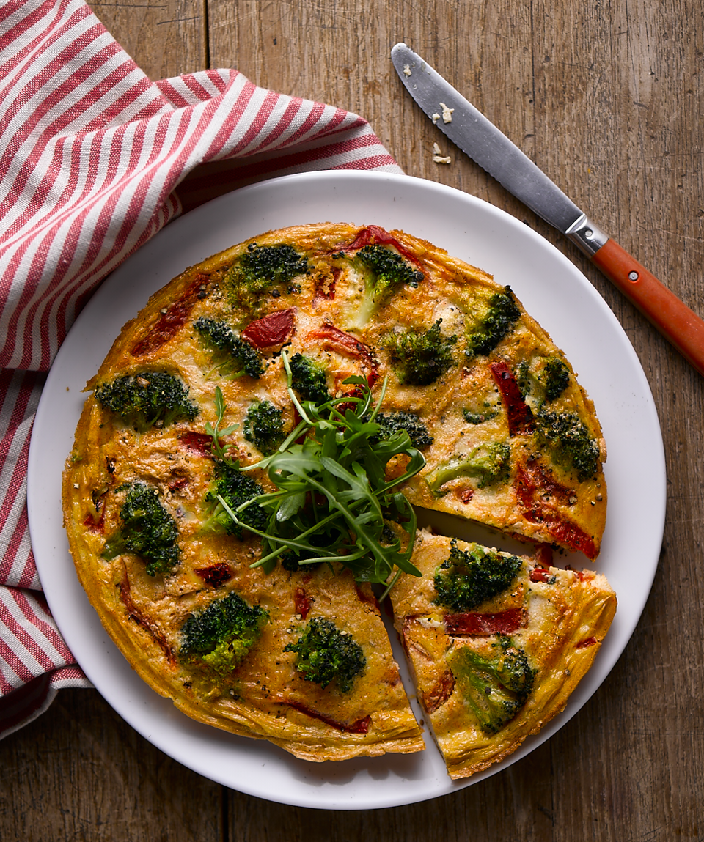
Broccoli Frittata

Preparation time: 15 mins
Cooking time: 30 mins
Serves: 4

Ingredients:

10 eggs
3 cloves of garlic, minced
Olive oil
1 head of broccoli
1 tsp paprika
Salt
Pepper
1 jar roasted red peppers

What to do:

- Boil a large pan of salted water and add the broccoli florets. Cook for 4 minutes then drain and run under cold water.

- In a separate bowl, whisk the eggs with the paprika, and salt and pepper. Put to one side.

- Now, in a large non-stick frying pan add some olive oil and start to fry the garlic on a medium heat then add the peppers and the broccoli. Toss the pan to cover the broccoli with garlic then add the egg mix.

- Put the whole pan in to the oven 160°C for 30 minutes.

For more information please contact The Little Big Voice on (0) 208 338 0188 or email pressoffice@thelittlebigvoice.com

